MY HOBBY

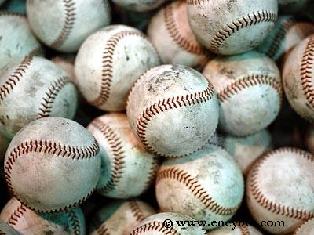
Baseball-Reference.com - Major League Baseball Statistics and History

My hobby is watching the baseball game.
Do you know this word? It’s not over until it’s over. With this quote in mind, i try myself to overcome adversity. This word means do not give up until end the game. So I’m often try, hard work, never give up. but it’s not major reason.
Baseball is fun. That’s the right reason I love. Thank you.

