**Analysis of Index of Housing Market for the Forecasting of the Apartment Housing Prices in Moscow**

Mina Ko

[komina5131@gmail.com](mailto:komina5131@gmail.com)

**I. Introduction**

The Housing Market is a very difficult, diverse and intricate for understandingsystem. Even if it is only the urban housing market there are millions of apartments with their own unique characteristics like the view from the windows, condition and design of the building, presence of a concierge. All these apartments are located in different regions of the city, each of which has own infrastructure and transport accessibility, has own level of ecological environment and own level of prestige.

By the beginning of last year by a citizen of Russia accounted for 23 square meters of housing (United States – 75 square meters, UK - 62 sq. m, Germany - 45 sq. m). By international standards it must be at least 30 meters. More than half of the residents of Moscow did not have their own homes or in need of better housing conditions.

So despite the complexity and intricacy of the Housing Market more and more people become interested in understanding a current stateand in timely tracking the new trends of the Housing Market.

**II. Housing Market in Russia**

The housing market in Russia began to develop in 1990, when it wasadopted the Law on Ownership of the Real Estate in USSR. The first real estate companies appeared in Moscow in the second half of 1990. Demand far exceeded supply but the development of the housing market suffered from a shortage of funds for potential buyers, price of 1 sq. m of housing was about $ 100. In 1992 privatization of housing began and the price rose to $250, and by the end of 1992 it rose to $708. Period 1990-1992 can be called an initial stage in the development of Housing Market in Moscow.

1993-1994 was a transitional stage. At that time the ratio of supply and demand evened by increasing income differentiation (At that time, many Russians began to engage in private business). The Housing price rose to $1120. Public authorities have increased their regulatory influence on the Real Estate (and Housing) market, developing a legislative and regulatory framework of the market.

1995-1997 was of the advanced market stage. In this period the market was characterized by transparency of information, sellers and buyers are versed in the value of the money, market conjuncture, reputation of the real estate companies. Price of 1 sq. m of housing was about $ 1235.

In 1998 begins the stage of stabilization of the Housing Market. Crisis of the stock and currency markets in Asia has affected the Russian stock market. Housing market prices continued to rise until August and then began to decline.

Since 2000 began a steady increase in real estate. The main reasons for the activation of the market were the overall economic growth in the country, political, financial and socio-economic stabilization.

**III. The structure of the Moscow housing market**

Existing and under construction in Moscow housing is very different in quality. There is no official data on the structure of the quality of housing, but according to available information the experts were able to do the next estimates (Chart #1)

Chart#1

Approximate data on the qualitative structure of the housing stock

|  |  |
| --- | --- |
| Category of housing | Data |
| Poor quality housing | More than a third(old housing stock, much of the "Khrushchev" houses, and the houses built before 1945) |
| A typical housing | Almost half (typical multi-storey panel building as well as "Stalinist" houses, to the same category should include many other houses from the 1960s-built) |
| High quality housing | About 10% (multi-storey brick house, including part of the "Stalinist" house of reinforced concrete, part of prefabricated houses in the South-West) |
| Luxury housing | About 2% (mostly reconstructed houses and individual apartments in the center and on the main highways, and new apartment buildings) |

Every year the city built housing the next quality categories: a typical (relatively low and average market prices) - about 85% of high quality (medium and high market prices) - up to 15%; elite (the most expensive in the city) - not more than 2%.

**III. Housing Market Index**

The real estate market has two parts - the primary market and the secondary market. On the primary market is selling apartments in new buildings, newly built, just starting to build or those that exist only in the project. Most often, the seller in the primary market is the one who builds or invests in building. Secondary housing market - the market of apartments bought and used before by their previous owners.

For the calculation of the index used in the main the secondary housing market data. The reason is that the secondary market is governed by the principle of supply and demand. Therefore, secondary market sets the price level and its dynamics in variety areas of the city. Why not the primary market? The primary market is mainly governed not economic but political and administrative principles. Price and its changes set by the builder or investor, who aims to get the most benefits. By the setting a price, the builder or the investor takes into account the prices of secondary market.

Monitoring the average prices and price indexes for Housing is held to study price changes in the Housing Market. The results of observations presented with ratings of average prices of 1 square meter of the total area of ​​apartments and their rates of change. An average price in housing market in Moscow is determined by the housing prices in some areas of the city.

Consider, for example, several charts of the price of housing in different parts of Moscow (Chart #2, 3, 4)

Chart #2

Chart of the price of Housing in Ostankinsky district.

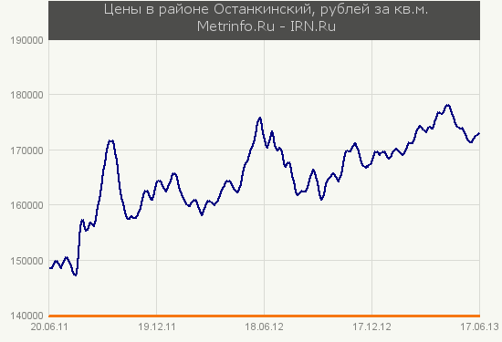

Chart #3

Chart of the price of Housing in Novogireevo district.

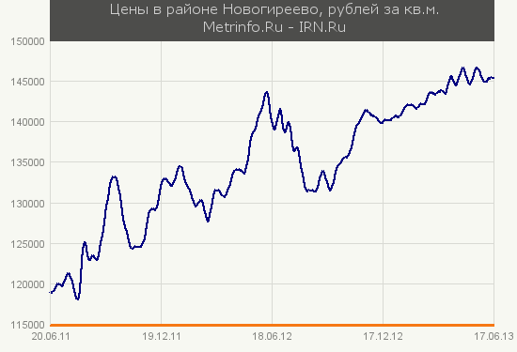

Chart #4

Chart of the price of Housing in Bibirevo district.

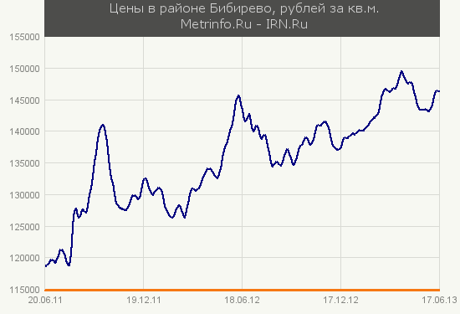

Shows that in spite of their specificity cost of housing vary approximately in proportion, that is, increasing or declining at the same time. From this we can conclude that all the causes affecting the value of a housing price can be divided into two main groups - local and global. To local causes include the view from the windows, condition and design of the building, presence of a concierge, location, infrastructure and transport accessibility, level of ecological environment and other. Global causes are related to macro-economic parameters such as the level of economic and business development in the city, the income level of the population and other.

Price of each apartment is determined by the general level of prices in the city - a reflection of the impact of global economic factors, and a set of local properties of the housing. Above can be expressed by the next symbolic formula:

Ck(t,pi)=G(t)+Lk(pi)

In this formula Ck(t,pi) - price per unit area (square meters) of k-th separate apartment in the moment of time t., pi - is the local parameters of the apartment, such as the location of the apartment, house type, etc. G(t) describes the contribution of global economic factors, and is a general level of prices in the city - one for all objects. The values ​ Lk (pi) are the contribution of local differences. They are different for each k-th apartment and depend on the set of her performance. As a first approximation adjustment Lk (pi) is independent of the time. We should take into account that the assessment adjustments Lk (pi) can be different. Some of them are additive as for example the cost of repairs per 1 sq.m., but most of the amendments are multiplicative. Therefore the values ​​of Li (pi) split into two parts and the above symbolic formula takes the form:

Ck(t,pi)=Ak(pi)*G(t)+Bk(pi)

Where Ak(pi) is the multiplicative and Bk(pi) is the additive adjustments. Written above expression is a scaled system of k equations where k is the number of apartments considered simultaneously. For the Moscow housing market it is from a few thousand to tens of thousands of apartments, depending on the selected databases and calculation step (weekly, monthly, or quarterly). This number of equations multiplies to another number of periods (e.g. weeks), during which the model is considered.

**IV. Analysis of Index of Housing Market**

Since 2005 housing prices in Moscow began to rise sharply and reached its highest mark in 2008. During this period prices increased by 25-30% per year. In time of Global recession in 2008 price of oil dropped from nearly 150 to 40 dollars per barrel. It greatly influenced on the economy of Russia, which is focused on the export of primary commodities. Housing prices have decreased more than 30%. With the improvement of the economy housing prices began to increase again but not as sharply as in the period before the crisis (Chart#1)

Chart#5

Housing price in Moscow from 1998 to 2012

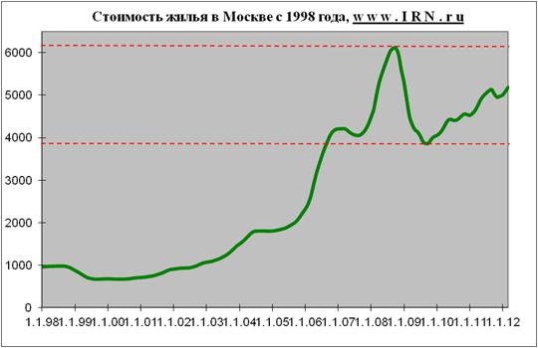

Since 2009 Housing price increases almost proportional to inflation, fluctuating in the range 4000-6000 dollars per 1 sq.m. (Chart #5)

Chart #5

Housing price in Moscow from 2008 to 2013

Most likely this situation will not change in the near future. On the one hand, Housing prices can not rise. The macroeconomic situation in the country and the world still remains difficult. For the past 3 years the problems caused by the crisis in 2008 have not been resolved. Economic situation of Greece, Portugal, Italy, Spain and the United States, it remains difficult. As well as the economies of these countries are somehow connected with the economy of almost all countries, the problem becomes global scale including relating to Russia.

Foreign investments in the Russian stock market go down, which led to a slowdown in business development. With the slowdown in business development decreased income of office workers. Because of rising world oil prices increase the prices of essential commodities (because the cost of gasoline lies in almost every product or service), resulting in decreased overall quality of life.

But Housing prices cannot also go down. In Moscow there are not very many areas suitable for building. So in Housing Market the supply is limited relative to demand. At the same time the number of people wanting to move to Moscow is not reduced.

**V. Conclusions**

Factors contributing to increase and factors contributing reductions Housing prices are approximately equal. Therefore the situation in the Housing market most likely will not change in the near future. Housing price will fluctuate in the range 10-20% depending on the influence of various factors. However, the relative price stability in terms of inflation actually means implicit cheapening of housing - by reducing the value of money.

**Bibliography**

1. Е.В. Гусева [Экономико-географический анализ рынка элитного и нетипового жилья в Москве](http://geopub.narod.ru/student/guseva/2/main.htm) - февраль 2002
2. <http://www.bci-marketing.aha.ru/content/struktura-i-segmentatsiya-rynka-zhilya-u-na-primere-moskvy>
3. <http://www.mirovoy-crisis.ru/finansovy-crisis-v-rossii.php>
4. <http://www.ocenchik.ru/rindex/?lim=12>
5. Асаул, С. Н. Иванов, М. К. Старовойтов. Экономика недвижимости, 2009
6. [www.irn.ru](http://www.irn.ru)
7. www. arsagera.ru
8. <http://www.metrinfo.ru/districts/>