**The Property of Elderly Poverty and Their Welfare Policy Solutions[1]\***

Deokho Cho

School of Public Administration, Daegu University

[chodh@daegu.ac.kr](mailto:chodh@daegu.ac.kr)

<http://cms.daegu.ac.kr/chodh>

Yunhee Seo(Research fellow)

Gilwhan Park[2]**

Prof of Daegu University

Abstract

The welfare policy recently is one of the most debatable issues in Korea. And this debate will be continued because of the change of population structure and the high welfare demand. Population aging is one of the world-wide phenomena which are directly related to the rise of the life expectancy and/or the declining of birth rates, especially in the developed countries. This study aims at finding the structural problems of the Korean elderly household poverty and suggesting some policy alternatives for the elderly households. Panel analysis model can handle the cross-sectional and longitudinal mega data. It also implements the individual and group effect analysis, based upon the change of time. And it suggests the welfare policy alternatives for the elderly households.

1. **Introduction**

The welfare policy recently is one of the most debatable issues in Korea. And this debate will be continued because of the population structure. Population ageing also is one of world-wide phenomenon that occur*s* due to the rise of the life expectancy and/or the declining of birth rates. This issue has been initially in the more economically developed countries but also do more recently in less economically developed countries. Especially Korea has been experienced the most rapid economic growth in the world for the last four or five decades and jumped from one of the most desperate country into the more economically developed one. Moreover the speeds of population aging and declining of birth rates have dramatically been increasing and these problems have been changed into social issues. Sooner or later they will gradually be developed into the social burdens and risks. This study aims at figure out the nature of elderly poverty and suggests the policy alternatives for the elderly welfare policy.

Especially the Korean elderly usually did not have opportunities to prepare their lives in terms of economic or social aspects such as an individual saving or public pension, and social network. The most of their energies eventually has invested in the economic development and education of their children. Moreover, this generation supports her parents with the breeding of her children simultaneously under the culture of the multi-generation family. However, this culture is not maintained no longer because their children move out from her home for the job or other reasons. Especially the rural elderly lives are very serious because most of young people move out to the urban areas. Eventually the structure of population cohorts can be presented like Figure 1. Its structure in 1960 was a typical pyramid type, pot one in 2011, but will be a reverse pyramid types in 2050. If this trend is continued, these changes of population structure will results in the serious aging and social problems such as elderly poverty and their welfare along with the decrease of total populations.

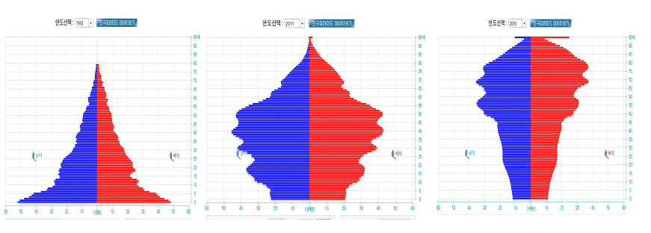

**<Figure 1>. The Changes of Population Structure Year 1960, 2011, and 2050 from the Left**

Source: the Korean Statistics Offices (<http://sgis.nso.go.kr/pyramid/view_country.asp>), Population Pyramid, 2011.

Many young generations do not live no longer in rural communities and the elderly people only live in their hometown without the help of their children. Actually rural communities are a kind of empty nests which young generation moves out and no children. It means that the Korean elderly, especially the rural elderly should solve their living and other costs by themselves. The poverty of general households comes from several different factors such as individual, household, working circumstance, health condition, and sociological factors. The elderly poverty might differ from those of general households. However, it is very difficult to solve the living costs because the elderly households are already retired or reached to the age of retirement along with the weak public pension system. Therefore they can easily fall into the poverty level. And then the poverty of elderly people is gradually changed into a big social problem.

Eventually the Korean government recently adopts the Farmland (year 2011) and Housing Pension Systems (Cho and Ma, 2007; Cho, 2012). Both systems actually are a reverse mortgage system which is not the pension system for but they intend to resolve the problems of elderly poverty and to supplement weak public pension systems (Cho, 2012). These systems are liquidated monthly from the elderly farmland and housing assets for their living costs (Cho, 2012). However these pension systems are not popular for the elderly people until now due to the weak tax supporting system, opposition of their children, and other cognition problems for using these pension systems. In spite of these problems, there are few researches (Cho, 2012) on the specific poverty characteristics of elderly households. Therefore, it is necessary to figure out the characteristics and causality of poverty of elderly households and these empty nests should be supplemented by the young people and economic activities. It also should find out the policy solutions to eliminate the poverty of elderly people.

The goals of this study are to figure out the structural problems of the Korean elderly poverty and to suggest some policy alternatives for the aging society, especially distinguishing the general elderly household with the poor one. In order to do that, it investigates the variables which affect on the elderly poverty using the Korean Five Year Welfare Panel Data from 2006 to 2010. Second, these date sets will be merged by year and personal identification, and notes the impact levels on the elderly poverty, comparing with the minimum living costs of elderly people. Third, it try to identify the better alternatives to handle the mega panel data, and establishes the causal relation models like the ordinary, logistic, and panel regressions theoretically and methodically. Finally this study will suggest the policy alternatives for each household to mitigate the elderly poverty and to promote the well-being living.

1. **Theoretical Reviews of Elderly Poverty**

In general, the origins of poverty can be categorized as the individual and social factors (Kang, 2007). However, these usually are shown up through the interaction between two factors. At first, individual factor on the poverty came from the human capital theory, choice theory, work competitiveness, and individual choice theory. Social factors come from the division of labor market and class theory. Moreover, there are a lot of researches on the poverty problems of ordinary households in several different aspects such as individual, socio-economic and even psychological aspects (Hong, 2004; Gu, 2005; Kim, 2006; Shon and Kim, 2006). However, there are few researches on the elderly poverty using the mega panel data.

The causes of elderly poverty are very arguable and some researches analyses the characteristics of elderly poverty (Cho, 2012; Cho, 2008 and 2009). Therefore living costs of considerable amount of elderly households are under the line of the minimum living costs (<http://www.index.go.kr>; 2013.01.07). It means that the poverty problems of elderly people are much more serious than those of the general households. Moreover, the single elderly household has been dramatically increased and this trend will be continued (Kim, 2011). These statistics are the highest level among OECD countries and these problems come from the weak social security system and the disorganization of family structure from the multi-family to the single-one and so on. The absolute and relative poverty rates are stagnated during the last 8 years like Table 1 even if the nation-wide economy has been grown up continuously.

Table 1. Poverty Rates by years (unit: %)

|  |  |  |  |  |  |  |  |  |
| --- | --- | --- | --- | --- | --- | --- | --- | --- |
|  | **2003** | **2004** | **2005** | **2006** | **2007** | **2008** | **2009** | **2010** |
| **Absolute Poverty Rates** | 6.9 | 6.9 | 7.9 | 7.7 | 7.7 | 7.8 | 8.1 | 7.1 |
| **Relative Poverty Rates** | 11.1 | 11.8 | 12.4 | 12.1 | 12.6 | 12.6 | 12.2 | 12 |

<http://www.nso.go.kr> (03, 03.2013)

Eventually the number of the elderly households has been increased from 1,730,000 in 2000 to 2,980,000 in 2010. Especially single-elderly households did from 540,000 to 1,020,000 in the same period (Kim, Junggun, 2011). Moreover, the young generation lives no longer with their parents together and they also do not support their parents like the ancient Korean culture. It means that the elderly should solve the problems of living costs by themselves under the weak social security system.

However, there are few researches on the reduction policy of the elderly poverty in spite of several researches on their poverty problems. Kim and Kim (2011) analyses the poverty problems of elderly households in terms of sex and job types. Their study has some weaknesses in analysis of job characteristics because they already retired from their jobs in spite of the significance of sexual differences on elder poverty. Eventually most of elderly people do not have their own jobs for the regular income. Choi (2009) notes the cause variables for elderly poverty and its solutions on each causal variable for improving the elderly poverty. However, it only describes the causal variables such as individual, family, and working factors, and resolvable factors on the elderly poverty. And then it cannot suggest the specific resolutions of poverty reduction because it does not implement the causal relation analyses. Suk (2010) analyzes the effects that the Basic Aging Pension System reduces the elderly poverty. And it contributes a little bit to reduce the elderly poverty due to small amount of payment and as a result cannot be a solution for reducing the elderly poverty.

General characteristics of elderly households are the same with Table 1. Most of elderly households are fallen into under the poverty due to the weak social security system. They also do not have the other income sources. Table 2 notes the social economic characteristics of elderly households.

Table 2. The Ordinary Characteristics of Elderly Households

| **Variables** | **N of elderly** | **Means** | **Standard**  **Deviation** | **Mini-**  **mum** | **Maxi-**  **mum** |
| --- | --- | --- | --- | --- | --- |
| |  | | --- | | general | | cin | | din | | nhousehold | | ownership | | workable | | healthstat | | cityrural | | sex | | age | | |  | | --- | | 10900 | | 10900 | | 10900 | | 10900 | | 10900 | | 10900 | | 10900 | | 10900 | | 10900 | | 10900 | | |  | | --- | | 0.269 | | 1384 | | 1299 | | 1.855 | | 2.011 | | 1.871 | | 3.384 | | 1.399 | | 1.393 | | 1934 | | |  | | --- | | 0.444 | | 1442 | | 2906.56 | | 0.924 | | 1.519 | | 0.984 | | 0.986 | | 0.490 | | 0.488 | | 5.855 | | |  | | --- | | 0 | | -4365 | | -239088 | | 1.000 | | 1.000 | | 1.000 | | 1.000 | | 1.000 | | 1.000 | | 1910 | | |  | | --- | | 1.000 | | 42960 | | 41124 | | 8.000 | | 9.000 | | 4.000 | | 9.000 | | 2.000 | | 2.000 | | 1947 | |

(See the variable name in p.11)

More specifically the poverty level of elderly households depends significantly on the sex of household heads. The poverty rate of female households is considerably 1.5 times higher than one of the male households. But there are no significant differences in case of control of the level of education and the spouse death. It comes from the lower education of women and the longer life expectancy (NWLC, 2010, 2012). Suk and Lim (2007) argue that the female gender effects negatively on the total income level in case of control of variables of personal and household characteristics. On the other hand, Hong (2005) and Choi (2007) note that there are no significant differences among the gender groups in case of control of variables of personal and household characteristics.

Second, the age of elderly people highly affects the poverty rate. For instance, age 75 or more groups easily fall into poor groups. However, it is also interrelated with household type, sex and other household characteristics. Therefore, the age effects cannot be separated from the other effect components. Eventually Choi (2007) argues that the age effects on the elderly poverty is shown up in the female households but not do in the male households.

Third, the level of education also affects the elderly poverty. Usually the higher education guarantees the highs income. However, most of the current Korean elderly groups were born in the period of Japanese colonization before 1945. At that time most of people were very poor and they did not have some chances to go to school. As a result the level of their school education is relatively very low, comparing with the next generation. Therefore, education level might not be a key variable in analyzing the elderly poverty (Choi, 2007, Cho, 2012).

Forth, homeownership, working ability, and job are also some of the key variables in determining the elderly poverty. Many scholars argue that the poverty level of elderly households highly depends on their previous jobs and homeownership (Hong, 2007; Choi, 2009; Cho, 2013; Suk and Lim, 2007). However, this argument is not enough to explain the poverty level of elderly because they are already retired from their jobs (Choi, 2007). These arguments might be reasonable in two aspects which they do not have special social security systems such as the education and public servant pension systems or they do not have enough financial savings

Fifth, public pension system is one of the most important factors for the elderly living. However most of these elderly groups already retired from their jobs and they do not have the public pension systems except some special groups such as the public servants and other private sectors. And most of elderly do not have their aging security system because the National Pension system was established very recently (Choi, 2007; Choi, 2009). Therefore, this paper does not include the pension system because pension data also is not enough to analyze the factor of poverty elimination for the five year time periods

In summary, there are many factors to effect on the elderly poverty and many scholars analyses the determinant factors to them. However, the key problems of elderly poverty generally are composed of personal, the structure of family, work, and social security systems. The characteristics of the Korean elderly poverty might differ from those of other developed countries because they experienced the rapid urbanization, change of population structure, family disorganization, high education costs for their children, and weak social security systems. And they also do not have the opportunity to prepare living costs of old age.

Most of studies focused on the poverty level of elderly people in the descriptive aspects but they did not analyze the causal relationship. Moreover, in terms of research methods, they note static characteristics of poverty using cross-sectional data except Choi’s study (Choi, 2009, Cho, 2012). They do not distinguish city and rural households, and poor and general ones which are one of the basic characteristics of elderly poverty. Therefore, the previous studies could not figure out the characteristics of elderly poverty by regions and income levels. In theoretical aspects, this study analyses the elderly poverty of ordinal and poor households considering the above four review of literatures, based upon the five year welfare panel data. In analysis method aspects, it implements the regression analysis in order to note the cross-sectional effects, do a logistic model to handle the category variables, and excise the panel data analysis to analyze the cross-sectional and time-series effects.

1. **Data Description and Research Methods**
2. **Panel Data Description and Model Building**

There are some benefits when the panel data analysis compares with the time series and cross-sectional ones. At first, the cross-sectional analysis only estimates the static relation among the variables at the specific time because it surveys several objectives at the decided time. However, panel data also can estimate the dynamic relationship because objectives are surveyed repeatedly following the time change. Second, the panel analysis also can consider the factors of the unobserved heterogeneity of objectives. And then the panel analysis can reduce the errors of model building. Third, the panel data can provide the time series and cross-sectional ones with the more information and variability of variables. It results in the efficient estimators and mitigates the multi-collinearity (Min and Choi, 2012).

This study uses the Korean Welfare Panel Data (KWPD) which the Korean Institute for Health and Social Affairs (KIHASA) and Institute of Social Welfare in Seoul National University have released the year base panel data every year from 2006. These data sets basically are composed of the individual, household, welfare, handicap, and children surveys. This study used the household panel data for analyzing the elderly poverty characteristics. This household data set is composed of the general characteristic variables of households, health and medical, economic activity, insurance and pension, dwelling, living costs, income and so on. This study selects the general variables out of on the household data set, considering the data availability and previous theoretical reviews.

This study merges year base data set to the these 5 year data sets longitudinally, using household merge key to build the panel data set of elderly households like Table 1. The merged data set is composed of age 65 or more elderly household data which are extracted from each whole age data set. Total observations of the merged data set are 10290 households. Based upon the previous theoretical reviews, this paper chooses a dependent variable (general) which is dummy variable as a proxy variable of poverty (Cho, 2009; Cho, 2012). It also implements the logistic, and panel analysis, and panel logit model.

Table 3. The Structure of the Korean Welfare Panel Data

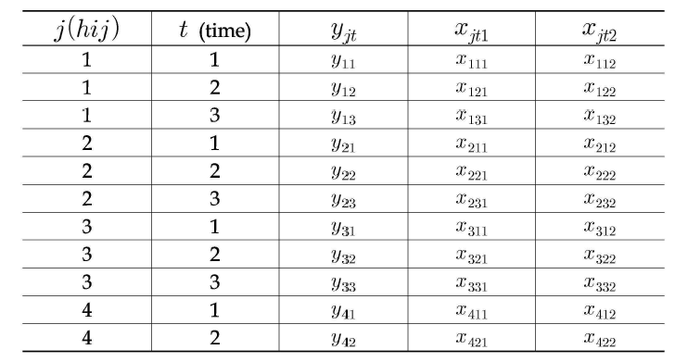

*J= 1………..m (unit of sample: ex: household), i=1………n (survey area; ex: school, class), h= (survey area; ex: region, city), t=1….T (wave), yjt =the value of response variable in time t, xjt=the value of explanatory variables in time t.*

The reasons that the elderly households fall into the poverty level are caused by the several factors like the above theoretical reviews. This paper distinguishes a general household and a low income one in order to figure out the characteristics of elderly poverty and why they fall into the poor households? The poor elderly household means below 60% of middle level income of general household. If the household income of elderly people is more than 60% of the middle level household income, it is called as general household (Choi, 2007; Cho 2009; 2012). And then this paper chooses nine independent variables such as ordinary income, nhousehold, ownership, healthstat, marriage, workable, region, sex, and age which are related with poverty issues in theoretical reviews and methodology aspects, considering 5 year panel data availability.

In terms of analysis method aspects, this paper intends to figure out the better alternatives for analyzing the panel data and adopts three different methods the ordinary, logistic regression, and panel analysis. It establishes a panel data set through merging 5 year cross-sectional data longitudinally by merge key variable. This paper implements three different methodologies for cross-sectional regression model and weighted regression model considers the cross-sectional weighted effects. It also takes logistic regression model because the dependent variable is dummy one (general and low income households) but logistic model does not consider the longitudinal effects of panel data set. This paper finally establishes a panel regression model which reflects the longitudinal effects (group and time) for handling the 5 year mega panel data.

1. **Model Building**

Panel data analysis recently becomes popular in social science researches because several kinds of panel data have been released from the Korean Statistics Office and other organizations. In order to figure out the better alternatives of panel data analysis, this study implements the ordinary regressions, logistic, and panel analyses. It also compares with these methodologies each other. Panel analysis has several advantages such as cross-sectional and longitudinal analysis of panel data (Seo, 2001). More specifically, this method can analyze the fixed effects which are composed of the group and time effects that are presented by wave, and also do the random effects such as the one and two-way effects. These two random models can be combined with the time effects (Kim, 2012). This study focuses the random and time effects but it does not consider the fixed effect because that there are too many observations (10290) which the fixed effects analyze the individual effects.

In brief analysis of KWPA, total 10290 elderly observations which are extracted from whole data sets are composed of ordinary (2649) and poor households (7641). It means that three quarters of elderly people already belongs to the poor households. And it also means that the elderly people are relatively very poor due to the weak income sources such as small amount of savings and weak pension system. 61.95% of the elderly people own their own housing, and 40.44% of elderly people live in urban areas (city) and others live in rural areas (Gun and City-Rural combination area). 60.03% of total elderly household heads are male and 39.97% are others. Moreover, the variables which are used in analysis are considerably correlated among variables following Pearson correlation coefficients.

This study takes three different analyses considering the structure of KWPD. At first, it adopts the logistics model (LM) because the dependent variable is a category variable. Secondly, it implements the random logit regression model (PRM) because KWPD is panel data which is merged by household-merge key for 5 year terms. Thirdly, it analyzes the fixed logit regression model (PRM) because KWPD is panel data which is merged by household-merge key for 5 year terms. And this paper will compare the analysis results in order to figure out which analysis is best fitted for analyzing the KWPA. And specific models are as follows.

Ordinary regression model can be described as follow:

 (1)

*Yi = dependent variable, βk = regression coefficients, xki = independent variables*

*i = number of observation, k = number of variables, ε = error term.*

Ordinary regression model does not consider the cross-sectional and longitudinal effects of 5 year panel data. It also assumes that a dependent variable is a continuous one. Logistic model and panel analysis also are adopted in this paper. It considers the dummy variable of the dependent one as follow (Cho, 2012). Dummy variables are ordinary and poor households (see Cho (2012) for specific method)). However, this model also does not consider the cross-sectional and longitudinal effects.

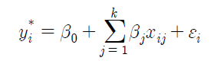 (2)

*Yi = Dependent variable (dummy variable), βj = regression coefficients, xij = independent variables, j = number of observations, i= number of variables, ε = error term.*

Panel analysis method is composed of fixed effects which are specific individual or specific time effects and random ones which are general individual or wave effects. This method will also be adopted in order to figure the cross-sectional and longitudinal effects of 5 year panel data. And this paper merges the five year welfare panel data longitudinally by group and time. The benefit of panel data can control unobservable individual heterogeneity. It also gets rich information about cross-sectional variations and dynamics. It moreover can avoid problems in time series data such as multicollinearity, aggregation bias and nonstationality. Finally it can identify individual and time effects which cannot be identified by pure cross-sectional or time series. However, it also has some problems as follows. Large parts of panel data are unbalanced. It also panel attrition and measurement errors (Kang, 2011). Panel analysis method can be presented like eq. (3).

*Yjt= α + βxjt + +μj + γt + εjt* (3)

*μj = parameters which present the group effects,*

*γt = parameters which present the time effects.*

This model includes group effects (group, region, individual, and so on) and time effects. Eventually this paper chooses one response and 8 explanatory variables due to these two reasons. It selects some representative variables based upon the theoretical reviews on the socio-economic characteristics of individual households for poverty analysis. It also considers data availability which is possible to merge five year panel data by the household key variable. Some variables are continuous but the others are category variables as follows:

*General=cin nhousehold ownership healthstat workable cityrural sex age*

*Dependent variable: general= dummy variable (1=general household; 0=low income household);*

*Independent ones: cin =ordinary income; nhousehold=number of householders; ownership=housing ownership (1=owner, 2= lump sum, 3=deposit rental, 4=monthly rental, 5=others); healthstat=(1= excellent healthy, 2= very, 3=moderate, 4=bad, 5=very bad); workable=(1=workability, 2=ill, 3=too old, 4=others); cityrural={(reg5(1,2,3)=2(city), sex=(man=1, female=2); age (the year who elderly people were born).*

1. **Analysis of Welfare Panel Data**

This study implements a logistic regression, and panel logit analysis (group and time for RanOne and RanTwo analyses) in order to figure out the better policy alternatives for elderly poverty and some appropriate methods for using the five year mega Welfare Panel Data. There are some different results in model fitness and individual variables.

More specifically, it implements the logit regression analysis like equation (2). 9627 observations among 10900 ones are used. This model is fitted in analyzing these kinds of panel data. Moreover, each variable has expected sign and Pseuda R2 is 0.8331

Table 4. The Results of Logistic analysis of Panel Data

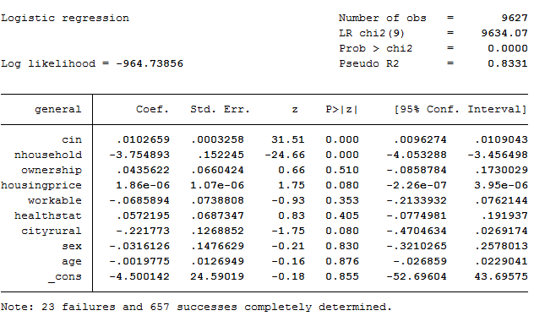

In order to resolve the logistic analysis problems in using panel data, this study implements panel logistic analysis. Panel logistic regression model composed of the fixed and random effects. The former is composed of the effects of specific objective and time, and the latter is made up of those of general objectives and times. Random effect model assumes the probability distribution of error term *μi* which presents the object characteristics of panel. And the value of rho means the proportion of variation of *μi* in the variation of total error term. Therefore, if the value of ρ is closed to 1, the object characteristics of panel should be significantly considered in analyzing the model. In table 5, the null hypothesis is rejected and this model is well fitted.

Table 5. The Results of Random Logistic Analysis of Panel Data

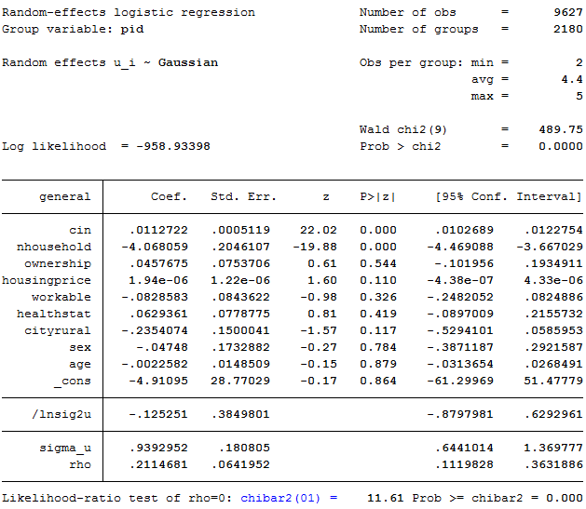

In the panel logit model, a set of predictors is identified which assesses the most likely of the two nominal categories a particular case falls into. The predictor variables may be any type of variable including general households. Table 6 is the results of marginal effects of random effect model. Under the assumption that the other conditions are constant, the marginal effect of variable cin is 0.112%. It means that if cin increases 1 unit, the probability that the poor household becomes the general household increases 0.112%. Especially, if nhousehold increases 1 unit, the probability that the ordinary household becomes the poor one increases four times.

Table 6. The Results of Marginal Effect of Logistic Analysis of Panel Data

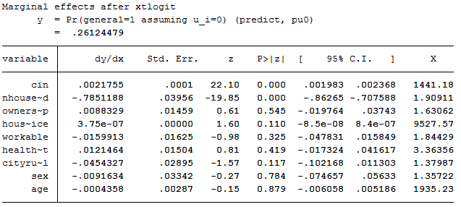

In order to estimate the fixed effect logit model, if all variable general (dependent variable) value of each panel object is 0 or 1, these objects are eliminated in the analysis like note in Table 7. And then 690 panel groups are used in this analysis. Logit, random, and fixed effect model are the same sign but coefficient of variables are some different.

Table 7. The Results of Fixed Logistic Analysis of Panel Data

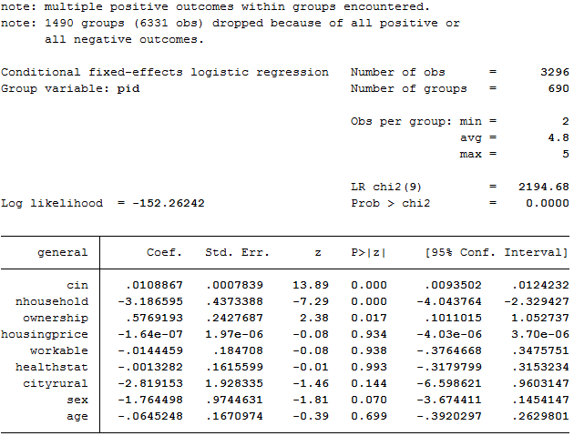

The previous three model shows that the sign of coefficient usually are the same but the value of coefficient are slightly are different (see table 8). More specifically, variable cin and nhousehold are significant at 1% in three different models. Sign of coefficients also is similar to the expected one. This means that regular income (variable cin) of elderly people is key factors to resolve the poverty problems in positive aspects. It also notes that number of household is also strong negatively related to the elderly poverty. In addition variable ownership housing price is significant at 0.1%. The dwelling location (variable cityrural) is significant at 10% in the fixed effect panel logit model and logit one.

These results mean that the elderly household

Table 8. The Results of Comparison with three different models of Panel Data

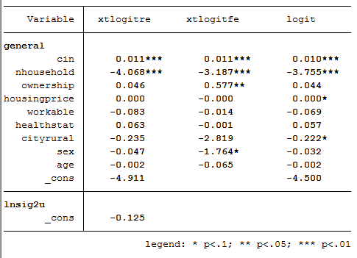

1. **Conclusion and Policy Implications**

This study implements the binary logistic regression, and panel analysis (group and time for RanOne and RanTwo analyses) in order to figure out the characteristics of elderly poverty and some appropriate methods for using the five year mega Welfare Panel Data.

In theoretical aspects, poverty level of elderly people is influenced from the ordinary income, number of households, ownership, health status, workable, city-rural, sex, and age variables. However, health status and marriage variables are not significant at 5% level or impact factors are very low even if the analysis results are different according the analysis models. More specifically, the poverty of households comes from several different factors such as individual, household, working circumstance, health condition, and sociological factors. However, the elderly poverty differs from those of general households. This study concludes as follows; first, in order to prevent that the elderly people fall into the poor level; the government should create the job opportunity, increase the ordinary income, and provide the work place. Homeownership and sex are also important factor in the elderly poverty. The government provides the elderly people with housing tax exemption for female households along with the supplement of the public pension system.

In methodological aspect, this paper suggests the research methods how to handle the mega panel data cross-sectionally and longitudinally. Until now, most of research methods focus on the cross-sectional analysis such as regression analyses and logistic ones depending upon the characteristics of available data. However, these methodologies cannot consider the time-effects of data. On the other hands, time series models cannot handle the several explanatory variables and only trace the effects by the time change on the one or two variables longitudinally.

In the policy aspect, the poverty of Korean elderly is getting worse because the number of elderly population is continuously and dramatically increased and sooner or later Korea will fall into aged society. Therefore, the social pension system cannot cover the explosive increase of welfare demands. And it should establish a new welfare system such as Housing and Farmland pension system. Both a pension system and reverse mortgage system should be integrated for the elderly population. Finally it should be developed into the life time asset management system.

Consequently, panel analysis model can handle the cross-sectional and longitudinal statistic mega data. It also implements the individual and group effect analysis following the time change. However, this analysis also has some weakness. It cannot handle the cross-sectional and longitudinal aspects simultaneously. It also has some weakness to handle the category dependent variable. Therefore, logistic panel analysis method should be elaborated in order to analyze the category variables cross-sectionally and longitudinally.

**Reference**

Cho, Deokho (2008). The Study on the Introduction of Farmland Reverse Mortgage System (Farmland Pension) in Rural Area, Korean Rural Community Cooperation.

Cho, Deokho (2012). “Elderly Welfare Policy for the Aging Society,” The Korean Dwelling Welfare Policy (edited by Ha, Seungkyu), Parkyoungsa.

Cho, Yun-hwa (2009). Factors Affecting the Poverty: the focus on householder’s characteristics, Journal of Research on the social science, vol. 24. 1-13.

Choi, Jumsuk(2009). “The Cause of Elderly Poverty and Its Improvement Alternatives,” Journal of Korean Local Autonomy & Public Administration. 23(1): 457-476.

Choi, Okgum (2007). “The Study of the Impact factors of the Elderly Poverty-Analysis of Using the Panel Data,” Journal of the Korean Social Welfare, 59(1): 5-25.

Hong, Bakyei (2005). “The Study of the Poverty Trend and its Structure of the Korean Elderly,” Journal of the Korean Social Welfare, 29: 147-174.

Hong, Kyungjun (2004). “The Effects of Poverty Mitigation through the Public Pension System,” Social Security Research, 21(2).

Gu InHei (2005). Working Inducing Effects by the National Minimum Life Security System and its improvement alternatives, Social Security Research, 21(1).

Kang, Sukwhun (2011). “A Brief Review of Panel Data Analysis,” The Conference on the Sixth Korean Education and Employment Panel. KRIVET, 1-54

Kang, Seungmin (2007). A Study on Dynamic of Asset Poverty through the View of Labor Panel – Based on the possibility of asset poverty transferal-, Master thesis, Sungsil University.

Kim, Aremi (2006). “Poverty Duration Period and its decision factors, Department of Social Welfare of Seoul City University.

Kim, Junggun (2011). “Single Elderly Household in Aging Society – Characteristics of Income Change and its Implication,” SERI Economic Focus. Vol. 357.

Kim, Jungsuk (2011). “The Single Elderly Household in the Aging Society –Characteristics and Policy Implication of Income Changes,” SERI Economic Focus, Vol. 357.

Kim, Kyusung (2012). 7th Korean Education & Employment Panel, KRIVET, 1-42.

Kim, Sujung and Kim, Jungsuk (2011), “The Poverty of Elderly Married Households: the Effect of Sex and Jobs,” Family and Culture, 23(3), 63-91.

----------. 2012. Insecure & Unequal: Poverty and Income among Women and Families 2000-2011 ([www.nwlc.org](http://www.nwlc.org)).

National Women’s Law Center (2010), “Poverty among Women and Families, 2000-2009: Great Recession Brings Highest Rate in 15 Years,” <http://www.nwlc.org/resource/poverty>.

Seo, Jinkou (2001), “Analysis Method of Panel Data,” Rural Economics, 24(2), 93-102

Shon and Kim(2007). Poverty and Social Welfare Policy, Chungmok Institute.

Suk, Sanwhun (2010). “Analysis of the Effects of Poverty Reduction by the Basic Aging Pension System,” Journal of Welfare for the Aged, Vol. 50: 335-352.

Suk, Jungeun and Kim, Junggi (2007). “The Difference of Income Level and the Determinant Factors of Income Source,” Journal of the Korean Gerontology, 27(1): 1-22.

<http://www.index.go.kr>: 2013.01.07

[http://sgis.nso.go.kr/pyramid/view_country.asp 2013.01.08](http://sgis.nso.go.kr/pyramid/view_country.asp%202013.01.08)

<http://www.nso.go.kr>: 08,03. 2013

1. * This research was supported by the Daegu University Research Fund(20110274)
2. ** Corresponding Author