**The Potential Welfare Demand and Characteristics of Poverty of Baby Boomers Using Welfare Panel Data[1]**

Deokho Cho

School of Public Administration, Daegu University

[chodh@daegu.ac.kr](mailto:chodh@daegu.ac.kr)

<http://cms.daegu.ac.kr/chodh>

Gilwhan Park

Prof of Daegu University

Abstract

The welfare policy for the elderly recently is one of most debatable issue in Korea. And this debate will be continued because of the population structure. Population aging is directly related to the rise of the life expectancy and/or the declining of birth rates. The speeds of the population aging and declining of birth rates have dramatically been increasing and these problems have been grown big social issues. However, there are few researches on the elderly poverty who will be potential demanders of the social welfare. And they will gradually be converted into the social burdens and risks. This paper notes the characteristics poverty of baby boomers and focuses on how to handle panel data. This study aims at figuring out the structural problems of the Korean baby boomers poverty and suggesting some policy alternatives for building the welfare policy of the poor baby boomers. Especially panel analysis model can handle the cross-sectional and longitudinal statistic mega also implements the individual and group effect analysis following the time change.

1. **Introduction**

Population aging is directly related to the rise of the life expectancy and/or the declining of birth rates. The speeds of the population aging and declining of birth rates have dramatically been increasing and these problems have been grown big social issues. And they will gradually be developed into the social burdens and risks. Especially baby boomers (born in 1948-1957), the highest level of age cohorts, will be retired from their jobs. And welfare demands will be increased explosively sooner or later.

Especially the baby boomers that are age 55-65 years old are potential welfare demanders. But they usually did not have opportunities to prepare their old age life in terms of economic or financial aspects such as an individual saving or public pension like most of elderly people. The most of their energies eventually were invested in the economic development and education of their children. Moreover, this generation supports her parents with the breeding of her children simultaneously under the culture of the multi-generation family. However, this culture is not maintained no longer because their children move out from her home for the job or other reasons.

The poverty of households comes from several different factors such as individual, household, working circumstance, health condition, and sociological factors in theoretical aspects. However, the baby boomers poverty might differ from those of other general households. It is very difficult to solve living costs after retirement because they are already retired or are reaching into the age of retirement. Therefore the baby boomers easily can fall into the poverty level[2]. In order to resolve these problems, the Korean government recently adopts the Farmland (year 2011) and Housing Pension Systems (year 2007). Both pension systems actually are a reverse mortgage system which is not actual pension system, but these systems intend to resolve the problems of baby boomers poverty and to supplement weak public pension systems (Cho, 2012). Actually these systems liquidate monthly bases their farmland and housing assets for their living costs until they die (Cho, 2012). However these pension systems are not popular for the baby boomers until now due to the weak tax supporting system and other cognition problems for using these pension systems.

In spite of these problems, there are few researches on the specific characteristics of poverty of baby boomers which will sooner or later become a big welfare demand. Moreover the Housing and Farmland Pension systems become popular for the elderly people. Therefore, it is necessary to figure out the characteristics and causality of poverty of boomers households. It also should find out the policy solutions to eliminate the poverty of baby boomers and to cover the boomers welfare needs.

This study aims at figuring out the structural problems of the Korean baby boomers poverty and suggesting some policy alternatives for them who are potential welfare demanders. In order to do that, it investigates the variables which effect on the baby boomers poverty using the Korean Five Year Welfare Panel Data from 2006 to 2010. Second, these date sets will be merged by year and personal identification, and notes the impact levels on the baby boomers poverty, comparing with the minimum living costs of baby boomers people. Third, it also establishes the causal relation models using panel logit regression model for handling the panel data. Finally this study will suggest the policy alternatives for each baby boomer household to mitigate the poverty and to support their well-being lives.

1. **Theoretical Reviews of Baby Boomers Poverty**

The poverty rate of Korean elderly is the highest in Organization for Economic Cooperation and Development (OECD). Half of the Korean elderly households live in a state of “relative poverty,” whose income level falls into below 50 percent of the average household income of the nation. According to OECD, the relative poverty ratio among the elderly people was 45 percent in 2006, it one of two elderly households live in poverty. The figure is three times higher than the mean poverty rate among OECD countries, which stood at 13 percent. No other OECD countries’ elderly poverty level exceeded 40 percent (<http://www.koreatimes.co.kr>, 2013).

The minimum cost of daily living is to be set at \1.363 million per month for four members in 2010 by the Ministry for Health, Welfare and Family Affairs (US$1=\1,248). This figure is used as the standard for welfare payments (Kim et. al., 2010). The absolute poverty households have been decreased by the economic growth but the relative poverty have not improved in the same period. Moreover, the gap of income levels has been increased continuously and the low income group also has increased (Choi and Ryu, 2003).

<Table 1> the Minimum Living Costs by the Number of Household Members and Years



And then, these problems have developed into social problems and especially the change of the structure of population cohorts has deteriorated this social welfare problems and this trend will be continued in near future like Figure 1. Figure 1 explains several things such as the reduction of population, the ratio of gender, the change of future population structure, and so on including the future welfare demand.

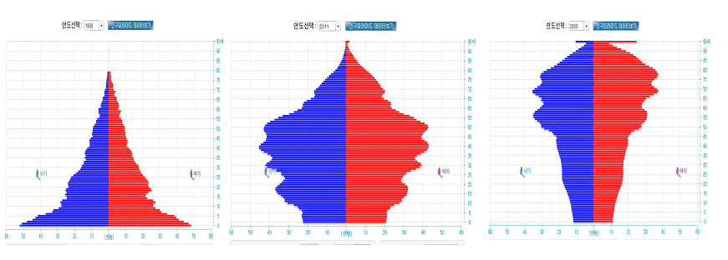

**<Figure 1>. The Changes of Population Structure Year 1960, 2011, and 2050 from the Left**

Source: the Korean Statistics Offices (<http://sgis.nso.go.kr/pyramid/view_country.asp>), Population Pyramid, 2011.

Based upon the previous reviews, we can easily project the poverty problems of Korean elderly because lots of elderly people already have retired from their jobs. Sooner or later, the demand of elderly welfare dramatically will be increased and poverty of these elderly people will be developed into social risks. Moreover, Korea didn’t have a good social insurance system for elderly people because the grown-up children traditionally supported their old parents, although Korea has started national pension system in 1988, the number of elderly who actually benefit from the National Pension system is still relatively low. Only 7 percent of elderly people can get the benefit from the National Pension system (<http://www.google.co.kr>: elderly poverty; 28, 01, 2013).

There are a lot of researches on the poverty of ordinary or elderly households (Hong, 2004; Gu, 2005; Kim, 2006; Shon and Kim, 2006). However, there are few researches on the baby boomers poverty which will be potential welfare demanders sooner or later. The poverty of baby boomers is very arguable and especially there are few researches about specific characteristics of baby boomers poverty. Especially there are no data on the minimum living costs for baby boomers, comparing with those of nation-wide general households.

In general, baby boomers reach to the period (age 55-64) of retirement from their jobs in general even if the time of retirement is different from job to one. But they cannot get the monthly payment form the National Pension System (NPS) until age 65 and they do not have the monthly income for about 10 years until NPS pays the month income at age 65. Moreover the significant amounts of baby boomers do not have any social welfare program. Therefore the living costs of lots of baby boomers are lower than the minimum loving costs because they should solve the problems of living costs (<http://www.index.go.kr>; 2013.01.07). It means that the poverty problems of baby boomers who retired from their jobs might be more serious than those of the general households.

Eventually significant numbers of them do not have the regular income sources. Moreover, the single baby boomers have been dramatically increased due to the high divorce rate and this trend will be continued (Kim, 2011; see Figure 1). They also are suffered the weak social security system and the disorganization of family structure from the multi-family to the single-one (Kim, Junggun, 2011). The young generation lives no longer with their parents together and they also do not support their parents like the ancient Korean culture. It means that the baby boomers should solve the problems of living costs by themselves under the weak social security system.

Total number of the surveyed elderly households (10900) is more than four times those of baby boomers (2590). General characteristics of elderly households are the same with Table 1. The ordinary and disposal income of baby boomers are more than two times those of elderly household. The table 2 shows the general characteristics of baby boomers. They maybe are located in the peak time of income level. However they should be retired from their jobs even if the retired time is different according their age and jobs. In other words, they have the possibility to fall into the poverty level due to the weak social security (see Table 2 for variable specification).

Table 2. The General Statistics of Ordinary Elderly Households

| **Variables** | **N** | **Means** | **Standard**  **Deviation** | **Mini-**  **mum** | **Maxi-**  **mum** |
| --- | --- | --- | --- | --- | --- |
| |  | | --- | | general | | cin | | din | | nhousehold | | ownership | | workable | | healthstat | | cityrural | | sex | | age | | |  | | --- | | 10900 | | 10900 | | 10900 | | 10900 | | 10900 | | 10900 | | 10900 | | 10900 | | 10900 | | 10900 | | |  | | --- | | 0.269 | | 1384 | | 1299 | | 1.855 | | 2.011 | | 1.871 | | 3.384 | | 1.399 | | 1.393 | | 1934 | | |  | | --- | | 0.444 | | 1442 | | 2906.56 | | 0.924 | | 1.519 | | 0.984 | | 0.986 | | 0.490 | | 0.488 | | 5.855 | | |  | | --- | | 0 | | -4365 | | -239088 | | 1.000 | | 1.000 | | 1.000 | | 1.000 | | 1.000 | | 1.000 | | 1910 | | |  | | --- | | 1.000 | | 42960 | | 41124 | | 8.000 | | 9.000 | | 4.000 | | 9.000 | | 2.000 | | 2.000 | | 1947 | |

(See the name of variables in p. 11

Table 3. The General Statistics of Ordinary Baby Boomers of Households

| **Variables** | **N** | **Means** | **Standard**  **Deviation** | **Minimum** | **Maximum** |
| --- | --- | --- | --- | --- | --- |
| |  | | --- | | general | | cin | | din | | nhousehold | | ownership | | workable | | healthstat | | cityrural | | sex | | age | | |  | | --- | | 2590 | | 2590 | | 2590 | | 2590 | | 2590 | | 2590 | | 2590 | | 2590 | | 2590 | | 2590 | | |  | | --- | | 0.6482625 | | 3124.12 | | 2876.02 | | 2.7023166 | | 1.7386100 | | 1.3000000 | | 2.8420849 | | 1.2559846 | | 1.2111969 | | 1949.42 | | |  | | --- | | 0.4776047 | | 2839.89 | | 2558.45 | | 1.1843394 | | 1.1893111 | | 0.7300587 | | 1.0587991 | | 0.4364975 | | 0.4082366 | | 1.8379116 | | |  | | --- | | 0 | | -23896.00 | | -24292.00 | | 1.000 | | 1.000 | | 1.000 | | 1.000 | | 1.000 | | 1.000 | | 1944 | | |  | | --- | | 1.000 | | 30020 | | 29552 | | 8.000 | | 5.000 | | 4.000 | | 9.000 | | 2.000 | | 2.000 | | 1955 | |

(See the name of variables in p. 11)

As the previous description, the reasons that the baby boomers fall into the poverty level are caused by the several factors. This paper distinguishes a general household with a low income one in order to figure out the characteristics of baby boomers poverty and why they fall into the poor households? Moreover, there are few researches on the reduction policies on the baby boomers poverty in spite of several researches on their poverty problems. Kim and Kim (2011) analyses the poverty of baby boomers households in terms of sex and job types. Their study has some weaknesses in analysis of job characteristics because they already retired from their jobs in spite of the significance of the analysis of sexual differences on poverty level. Eventually most of baby boomers do not have their own jobs for the regular income. Choi (2009) notes the causal variables for baby boomers poverty and its solutions on each causal variable for improving the baby boomers poverty. However, their study only describes the causal variables such as individual, family, and working factors, and resolvable factors on the elderly poverty.

First, in terms of individual factor, the poverty level of baby boomers depends significantly on the sex of household heads. The poverty rate of female household head is considerably 1.5 times higher than one of the male households (Choi, 2009; Cho, 2012). But there are no significant differences in case of control of the level of education and the spouse death. It comes from the lower education of women and the longer life expectancy (NWLC, 2010, 2012). Suk and Lim (2007) argue that the female gender effects negatively on the total income level in case of control of variables of personal and household characteristics. On the other hand, Hong (2005) and Choi (2007) note that there are no significant differences among the gender groups in case of control of variables of personal and household characteristics.

Second, in terms of socio-economic factor, homeownership, working ability, and job are also key variables in determining the baby boomers poverty. Many scholars argue that the poverty level of elderly people highly depends on their previous jobs and homeownership (Hong, 2007; Choi, 2009; Cho, 2012; Suk and Lim, 2007). These argument are reasonable in two aspects which they have weak social security systems and do not have enough financial savings. However, this argument is not enough to explain the poverty level of baby boomers because they are already retired from their jobs or still work in their jobs (Choi, 2007; Cho, 2012).

Third, in terms of social security factors, public pension system is one of the most important factors for the baby boomers living. However most of these baby boomers groups already retired from their jobs and they do not have the public pension systems except some special groups such as the public servants and other private sectors. Therefore most of baby boomers do not have their aging security system because the National Pension system was established very recently (Choi, 2007; Choi, 2009). Therefore, this paper does not include the pension system because pension data also is not enough for analyzing the factor of poverty elimination.

Forth, there are many factors to effect on the baby boomers poverty and many scholars analyses the determinant factors to them. However, the key problems of baby boomers poverty generally are composed of personal, the structure of family, work, and social security systems like the previous reviews. The characteristics the Korean baby boomers poverty differ from those of other developed countries because they experienced the rapid urbanization, change of population structure, family disorganization, high education costs for their children, and weak social security system. Therefore, and they do not have the time and room to prepare living costs of old age lives due to several reasons. Most of studies focused on the poverty level of elderly people in the descriptive aspects but they did not analyze the causal relationship and also did not care the baby boomers who are potential demanders for the public welfare.

In summary, this study aims at analyzing the baby boomers poverty of the general and poor households considering the above four major characteristics, based upon the five year welfare panel data. In terms of research methods, they note static characteristics of poverty using cross-sectional data except Choi’s study (Choi, 2009; Cho, 2012). They do not distinguish city and rural households and also not poor and general ones even if their poverty characteristics are different one another. Therefore, their studies could not figure out the characteristics of baby boomers poverty by regions and income levels. This study also tries to figure out the better alternatives for handling panel data. It excises the panel data analysis to analyze the cross-sectional and time-series methods.

1. **Panel Data and Research Methods**
2. **Panel Data and Circumstances of Baby Boomers**

The panel data has some benefits, comparing with the time series and cross-sectional ones. At first, the cross-sectional data only measures the static relation among the variables at the specific time. However, panel data analysis measures the dynamic relationship because an objective is surveyed repeatedly following the time change. Second, the panel analysis can consider the factors of the unobserved heterogeneity of objectives. And then the panel analysis can reduce the errors of model building. Third, the panel data can provide the time series and cross-sectional ones with the more information and variability of variables. It results in the efficient estimators and mitigates the multi-collinearity. However, the panel data also has some weaknesses. At first, it is difficult to get data due to the missing data by the repeated survey of time changes. There might be some group-wise correlations in case that national or regional panel group data are surveyed (Min and Choi, 2012). This panel analysis also has some weakness such as data collections, group-wise correlation, and computational costs and so on.

This paper use the Korean Welfare Panel Data which (KWPD) are surveyed by the Korean Institute for Health and Social Affairs (KIHASA) and Institute of Social Welfare in Seoul National University. This study uses the household data set from 2006 to 2010 in order to figure out the characteristics of baby boomers household poverty and its policy alternatives. The major contents of this data set are composed of household characteristics, economic activity, living cost, income and asset, housing and health, social insurance and basic life, workability, social welfare, and other family related factors. This study merges these 5 year data sets longitudinally using household merge key variable. The data sets of baby boomers (age 55-65) are extracted from these merged data sets. The merged data set has 2590 observations. These data sets are surveyed tracing each household at the nationwide and aim at establishing the policy for these poor groups after International Monetary Fund (IMF) economic crisis (<http://www.koweps.re.kr>: 02.04. 2013).

These panel data sets are very suitable for analyzing longitudinal analysis because these data sets contain the traced characteristics of each variable on the same household surveyed by interviewers. In terms of analysis method aspects, this paper adopts the panel logit analysis because it is panel data and the dependent variable is a binary data. Panel data models examine specific effects, time effects, or both. One of the main objectives of this study is how to handle the panel data. And it tests the methodologies such as ordinal regression, logistic, and panel analysis. The parameter estimate of a dummy variable is a part of the intercept in a fixed effect model and a component of error in the random effect model. Slopes remain the same across groups and time periods.

1. **Panel Data and Variable Specification.**

This paper implements the panel logistic model in order to analyze the binary and five year panel data for figuring out the poverty factors of baby boomers. The structure of panel data can be presented like Table 4.

**Table 4. The Structure of the Korean Welfare Panel Data**

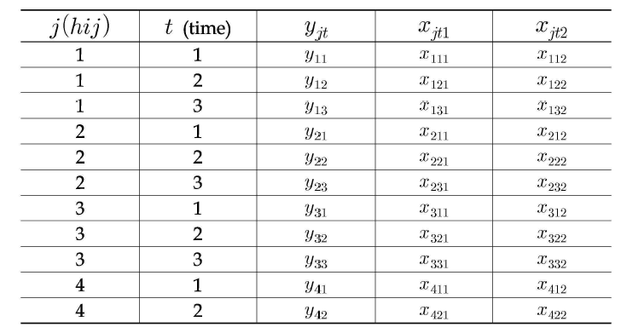

*j= 1………..m (unit of sample: ex: household), i=1………n (survey area; ex: school, class), h= (survey area; ex: region, city), t=1….T (wave), yjt =the value of response variable in time t, xjt=the value of explanatory variables in time t.*

In case of that the reponse variable is binary, the logistic regression method can be applied into the analysis of this panel data. The fixed effect is composed of the specific *i*th group effect and *t* wave one. And the random effects are composed of general group effects *(μi)* and general wave effects(*γt*). Eventually this paper chooses one response and 8 explanatory variables due to these two reasons. It selects some representative variables based upon the theoretical reviews on the socio-economic characteristics of individual households for poverty analysis. It also considers the availability of five year panel date which can be merged by the household key variable. Based upon the above criteria, it chooses the variables as follows:

*Dependent variable:*

*General= dummy variable (1=general household; 0=low income household);*

*Independent ones:*

*cin =ordinary income; nhousehold=number of householders; ownership=housing ownership (1=owner, 2= lump sum, 3=deposit rental, 4=monthly rental, 5=others); healthstat=(1= excellent healthy, 2= very, 3=moderate, 4=bad, 5=very bad); marriage=(1=livewithwife, 2=spouse death, 3=divorce, 4=separate); workable=(1=workability, 2=ill, 3=too old, 4=others); cityrural={(reg5(1,2,3)=2(city), reg5(4,5)=1(rural); sex=(man=1, female=2); age (the year who baby boomers people were born)..*

1. **Analysis of Welfare Panel Data**
2. **The Structure of Welfare Panel Data**

Total observations of baby boomers are 2590 households. In order to figure out the characteristics of baby boomers for building their welfare policy, several analyses can be chosen. This study tries to select the appropriate method for the panel data analysis. Ordinary regression model does not consider the longitudinal effects in analyzing the causal relationships. The logistic model also does not consider the longitudinal effects of panel data set. Panel regression model reflects the longitudinal effects (group and time). This paper can take panel model because of panel data set and the response variable is binary variable. This method recently becomes popular in social science researches because several kinds of panel data have been released. It has several advantages such as cross-sectional and longitudinal analysis of panel data.

This paper selects some variables as follows, based upon the results of correlation analysis. Dependent variable (relative income) is composed of ordinary and low income households who receive the basic living security services and do not receive from the government or other public agencies. A response variable is a household distinguished by the equalization of income. Independent variables are composed of the general characteristics of households, income, health, region, and so on. Specific variables will be presented in Chapter IV.

This panel logistic method can analyze the fixed effects which are composed of the group and time effects by the wave, and also do the random effects such as the one and two-way effects. These two random models can be combined with the time effects (Kim, 2012). It focuses the random and time effects but does not consider the fixed effect because that there are too many groups (2590).

This study implements the descriptive analysis on the poverty level in order to figure out the brief characteristics of the KWPA before doing the panel logistic analysis. It runs the frequency analysis. And it shows that total 2590 observations are composed of ordinary (1679: 64.83%) and poor households (911: 35.17%). More than a third of baby boomers are relative poor households under the poverty line. On the other hands, in case of age 65 or more, total 10290 observations of elderly households are composed of ordinary (2649: 23.99%) and poor households (7641: 74.26%). Moreover, 1310(50.58%) of ordinal households live in the city. It means that three quarters of elderly people already belongs to the poor households. It also notes that baby boomers households have significantly the possibility to fall into to the poor household after retirement. And moreover, it also suggests that the considerable amount of baby boomers is relatively poor even if their income levels are located in the highest peak in their lives. Moreover, they have some difficulties to get the monthly payment due to the weak income sources such as small amount of savings and weak pension system (actually pay pension at age 65).

The home ownership of the general households is 1679 households (64.637%) and that of the poor households is very low, actually 911 households (35.17%). It means that the poor baby boomers have the difficulty to solve the housing welfare. The general households who lived in the city are 1310 (50.88%) and 369 (14.25%) in the rural area. The poor households is each 617 (23.82 %) in the city and 294 (11.35%) in the rural area.

In the sex aspect of household head, the number of male general households is 1426 (55.06%) and that of female ones is 253(9.99%). In summary 1927 (74.40%) of baby boomers live in urban areas (city) and others live in rural areas (Gun and City-Rural combination area). 2043 (78.88%) of total baby boomers household heads are male and 547 (21.12%) are others.

1. **Building of Panel Analysis Model**

Panel data analysis recently becomes popular in social science researches because several kinds of panel data have been released from the Korean Statistics Office and other organizations. Panel (or longitudinal) data has simultaneously the structures of cross-sectional and time series. There are multiple entities and each component has repeated measurement at the different time periods. Panel data models examine group (individual-specific) effects, time effects, or both. These effects are either fixed effect model or random effect one, depending upon the assumption on the fixed effect or random effect. A fixed effect model examines if intercepts vary across groups or time periods. A one-way model includes only one set of dummy variables (e.g., firm), while a two-way model considers two sets of dummy variable (e.g., firm and year, (Park, 2009)).

Like EQ 1, error term ($μ_{i}$) presents the heterogeneity nature which changes, following the change of the panel objects. But it does not change but has the duration feature within a panel object. Panel logit analysis assumes that error term ($ϵ_{it}$) follows the logistic distribution. It is suitable for the binary response variable. This basic type of panel logit model is as follows:

If $y_{it}=1, y_{it}^{*}$ >0,

$y_{it}$ = 0, $y_{it}^{*}≤0$,

$y_{it}^{*}$ = $α+ {βx}_{it}+ μ_{i}+γ_{t}+ϵ_{it}$ (1)

$y_{it}$*= observed dependent variable, $y_{it}^{*}$ = latent real variable*

${ x}_{it}=independent variable$, ${ μ}_{i}=parameter which presents group effect$ s,

${ γ}_{t}=parameter which presents time effects$, $ϵ_{it}=error term$, $α, β=regression cofficients$

The fixed effects: ${ u}_{i}\left(fixed i\right): specific i^{th} object effects); γ_{t}\left(fixed t\right):specific t^{th} wave effects$,

The random effects: ${ u}_{i}\left(random i\right): general object effects; γ_{t}\left(random t\right): general wave effects$;

Error term ${(ϵ}_{it}$) is the real error which changes, depending on the change of panel objects and time. Panel logit analysis assumes that error term ($ϵ_{it}$) follows the logistic distribution instead of normal one (No and Back, 2012). More specifically, fixed effect models are composed of fixed group and time models. Fixed effect models are as follows:

Fixed group model $y_{it}$ = $\left(α+ μ_{i} \right)+ {βx}_{it}+γ_{t}+ϵ_{it}$, $ϵ_{it}$ ~ N (0, $σ_{ε}^{2})$

Fixed time model $y_{it}$ = $\left(α+γ_{t}\right)+ {βx}_{it}+ϵ_{it}$, $ϵ_{it}$ ~ ~ N (0, $σ_{ε}^{2})$

The model has the characteristics that r $egression coefficient \left(β\right)s$ are the same but the intercepts are different. Moreover; the model can be applied to OLSE, through the proxy variable. In order to figure out the better alternatives of panel data analysis, this study implements logistic, panel analyses, and panel logistic ones. It also compares with these methodologies each other to figure out the better policy alternatives. However, panel analysis has several advantages such as cross-sectional and longitudinal analysis of panel data in case of using the panel data (Seo, 2001). More specifically, this method can analyze the fixed effects which are composed of the group and time effects that are presented by wave, and also do the random effects such as the one and two-way effects. These two random models can be combined with the time effects (Kim, 2012). This study focuses the random and time effects but it does not consider the fixed effect because that there are too many observations (10290) which the fixed effects analyze the individual effects.

In order to solve these problems, this study adopts the logistic model like Table 2. Binomial (or binary) logistic regression analysis (LRA) is a form of multiple regressions which is applied when the dependent variable is dichotomous – that is, has only two different possible values. Like other forms of regression, logistic regression generates *β*-weights (or slope) and a constant. However, these are used to calculate something known as the logit rather than scores. The logit is the natural logarithm of odds which is $\frac{p}{1-p}$ in here *p* is the probability of any event occurs for the category. The percentage predicted in each category of the dependent variable can be calculated from this and compared with the actual percentage. The number of ordinal households is 1679 and that of poor ones is 911 ones. A dependent variable (general) is a latent one and is converted into dummy one. This process is changed from discrete distribution to binominal one but it is converted into its logistic probability (see Cho, 2012).

Table 5 notes that the logistic model is much fitted but some individual variables are not significant even at 90%. Even if stepwise option is applied in this model, iteration process is stopped in step 4. Odds ratio of nhousehold is 19.929 at 95% Wald confidence limits and it means that the probability which the baby boomers household falls into general households is 19.929 times higher than that of which the baby boomers household falls into poor households. The others odd ratio can be interpreted as the same way. And then a binary logistic multiple regression model itself is probably suitable for this panel data analysis to figure out the characteristics of poverty of baby boomers. However, this model does not consider the cross-sectional and longitudinal effects of panel data.

**Table 5. The Results of Logistic Regression Analysis**

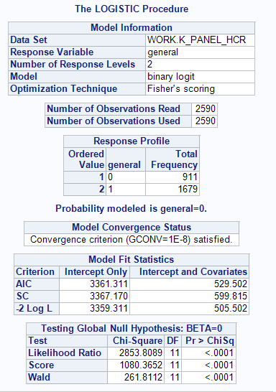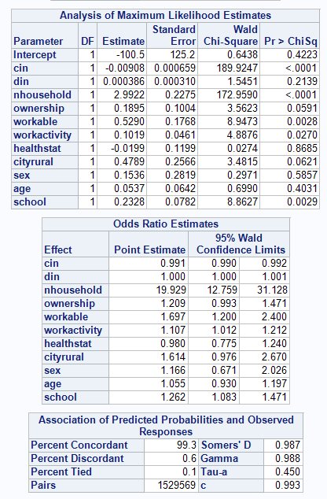

In order to solve the problems of logistics regression analysis using the panel data, this study implements the panel regression analysis (PRA) like Table 3. PRA is composed of the explanatory variables, group (personal or regional) effects, time effects, and error term. Fixed effect model is the different intercepts but the same *β* coefficient model (see Table 4). More specifically fixed effects are composed of the effect of the specific *jth* baby boomers people and that of the specific time of wave. On the other hands, RanOne effect models are the effects on the general baby boomers people and wave. *α* and *β* coefficients are constant numbers and variation of error term are changed according to the changes of group and time. This study focuses the fixed effects of waves because the coefficients of the fixed effects of specific household are more than 2057 one.

Table 6 shows that the fixed time effect model has the same *β* coefficient and but the cross sectional effects are different depending upon wave. It has *R2*=0.4127 and fixed time effect model itself is not significant. Moreover, most of explanatory variables are not significant at 99% significant level. Therefore this paper notes that the fixed time effect model is not suitable for analyzing KWPD.

**Table 6. The Fixed Time Effects of PRA**

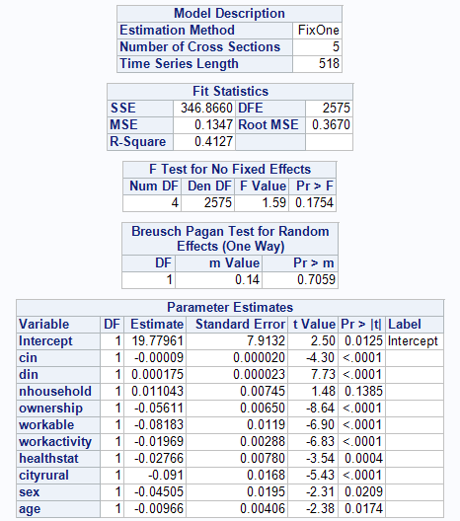

Random effect models are composed of the one-way and two-way effect models. These two models also are made up the general group and time effect models. Random one effect model has the same *α, β* coefficients and but the variation of error term are different according to group (*j*), and time (*t*) cross sectional effects are different.

${ y}_{it}^{*}$ = $α+ {βx}_{it}+ μ_{i}++ϵ_{it}$ $ϵ_{it}$ ~ N (0, $σ_{ε}^{2})$ (2)

One way random group effect model $y_{it}$ = $α+ {βx}_{it}+( μ_{i} +ϵ_{it})$

= $α+ {βx}_{it}$ + $δ_{it}$

Regression coefficient $α, β:$ constant

Error term variation (var $δ_{it})$: variation can en different from group (i) and time (t)

Error term co-variation variation ( $δ_{it} , δ_{it}^{*} )≠$ 0

Like the right one of Table 7, RanOne group effect model has *R2*=0.4100. Model itself is suitable and all explanatory variables are significant at 95% significant level. RanTwo group effects has *R2*=0.2606. Model itself is suitable and all explanatory variables except nhousehold and age are significant at 5% level. Based upon these previous analyses, RanOne analysis model is the most suitable for this welfare panel data.

**Table 7. The Random Group Effects of Panel Regression Analysis**

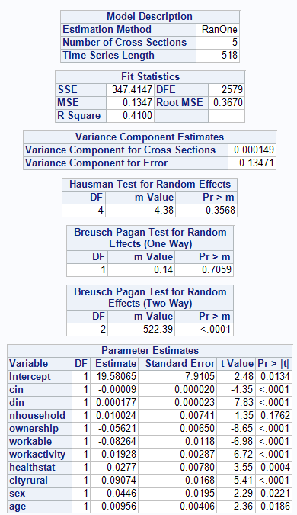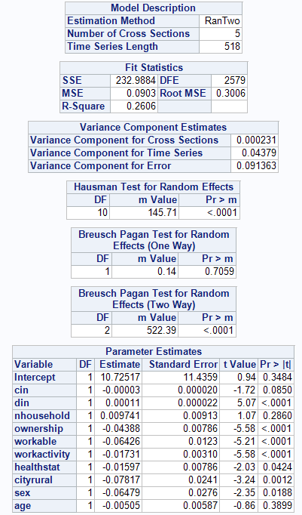

This panel data model has a binominal dependent variable instead of continuous variable. In case of binary dependent variable in cross-sectional data, logit and profit model are adopted, depending upon the probability distribution of error term. This paper takes a panel logistic model like Table 8. The test result of Likelihood-ratio rho=0 rejects the null hypothesis $σ_{μ}^{2}$.=0 It means that the object characteristics of panel should be considered.

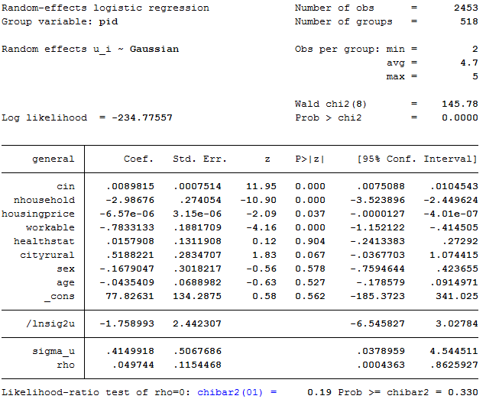

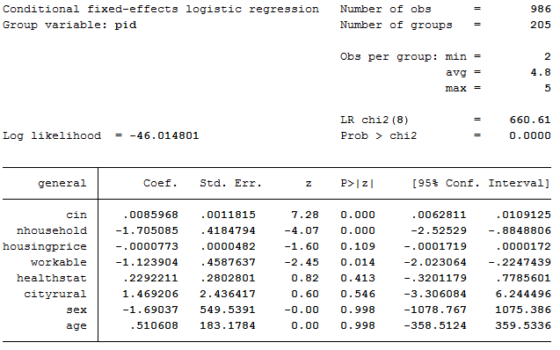

1. **Conclusion and Policy Implications**

The elderly welfare policy is a big social issue and directly related with the poverty problems. However, most of study focused on the elderly households instead of the baby boomers who are the potential welfare demand groups. This study implements the logit, panel analysis (group and time effects for RanOne and RanTwo analyses), and panel logit one in order to figure out the characteristics of baby boomers poverty and some appropriate methods for using the five year mega Welfare Panel Data.

In theoretical aspects, like the previous description, the poverty of elderly households comes from several different factors such as individual, household, working circumstance, health condition, and sociological factors. However, the baby boomers poverty differs from those of general households. Eventually the poverty level of baby boomers is influenced from several different factors such as the ordinary income, number of households, ownership, health status, workable, cityrural, sex, and age variables. However, health status and marriage variables are not significant at 5% level or impact factors are very low even if the analysis results are a little bit different according the analysis models.

This study concludes as follows; first, in order to prevent that the baby boomers fall into the poor households, the government should create the job opportunity to increase the ordinary income and to provide the work place because the job is one of the best alternatives to guarantee the baby boomers welfare. Homeownership and sex are also important factor in the baby boomers poverty. The governmental policy should provide the baby boomers with dwelling stabilization policy and dwelling support system like Boucher for female households along with the supplement of the public pension system.

In methodological aspect, this paper suggests a new research methods how to handle the mega panel data cross-sectionally and longitudinally. Until now, most of research methods focus on the cross-sectional analysis such as regression analyses and logistic ones depending upon the characteristics of available data. However, these methodologies cannot consider the time-effects of data. The cross-sectional analysis such as regression only measures the static relation among the variables at the specific time because it surveys several objectives at the designated time. Time series models cannot handle the several explanatory variables and only trace the effects by the time change on the one or two variables longitudinally.

Consequently, welfare policy is directly related with the job opportunity, especially for baby boomers. Moreover, poverty characteristics also differ from the age cohorts. Therefore, the government should create the diverse welfare system in order to prevent the poverty of the baby boomers because they are big social welfare demanders. In terms of methodology, the panel analysis model can handle the cross-sectional and longitudinal statistic mega data. It also implements the individual and group effect analysis following the time change. However, this analysis also has some weakness. It cannot handle the cross-sectional and longitudinal aspects simultaneously. It also has some weakness to handle the category dependent variable. In order to do that, logistic panel analysis method should be elaborated.

**Reference**

Cho, Deokho (2008). The Study on the Introduction of Farmland Reverse Mortgage System (Farmland Pension) in Rural Area, Korean Rural Community Cooperation.

Cho, Deokho (2012). *“Baby boomers Welfare Policy for the Aging Society,”* The Korean Dwelling Welfare Policy (edited by Ha, Seungkyu), Parkyoungsa.

Cho, Yun-hwa (2009). *Factors Affecting the Poverty: the focus on householder’s characteristics,* Journal of Research on the social science, vol. 24. 1-13.

Choi, Hyunsu and Ryu, Yunkyu (2003). *A Study on the Trend and Structure of Elderly People in Korea*, Journal of the Korean Gerontological Society 32(3), 143-160.

Choi, Jumsuk(2009). *“The Cause of Baby boomers Poverty and Its Improvement Alternatives,”* Journal of Korean Local Autonomy & Public Administration. 23(1): 457-476.

Choi, Okgum (2007). *“The Study of the Impact factors of the Baby boomers Poverty-Analysis of Using the Panel Data,”* Journal of the Korean Social Welfare, 59(1): 5-25.

Hong, Bakyei (2005). *“The Study of the Poverty Trend and its Structure of the Korean Baby boomers,”* Journal of the Korean Social Welfare, 29: 147-174.

Hong, Kyungjun (2004). *“The Effects of Poverty Mitigation through the Public Pension System,”* Social Security Research, 21(2).

Gu InHei (2005). Working Inducing Effects by the National Minimum Life Security System and its improvement alternatives, Social Security Research, 21(1).

Kim, Aremi (2006). *“Poverty Duration Period and its decision factors,”* Department of Social Welfare of Seoul City University.

Kim, Junggun (2011). *“Single Baby boomers Household in Aging Society – Characteristics of Income Change and its Implication,”* SERI Economic Focus. Vol. 357.

Kim, Jungsuk (2011). *“The Single Baby boomers Household in the Aging Society –Characteristics and Policy Implication of Income Changes,”* SERI Economic Focus, Vol. 357.

Kim, Kyusung (2012). *7th Korean Education & Employment Panel,* KRIVET, 1-42.

--------------- (2012). Regression Analysis using the Korea Education and Employment Panel Data, 7th KEEP Conference.

Kim, Migon et. al., (2010). The Survey on the Minimum Living Costs, Policy Report 2010-58.

Kim, Sujung and Kim, Jungsuk (2011), “*The Poverty of Baby boomers Married Households: the Effect of Sex and Jobs,”* Family and Culture, 23(3), 63-91.

----------. 2012. Insecure & Unequal: Poverty and Income among Women and Families 2000-2011 ([www.nwlc.org](http://www.nwlc.org)).

Korea Institute for Health and Social Affairs (KIHASA) and Social Welfare Research Institute at Seoul National University (2006, 2007, 2008, 2009, 2010), Korean Welfare Panel Study: User’s Guide (http://www.koweps.re.kr).

Min, Insik and Choi, Philsun (2012). Stata Panel Data Analysis, Jipil Media

National Women’s Law Center (2010), “Poverty among Women and Families, 2000-2009: Great Recession Brings Highest Rate in 15 Years,” <http://www.nwlc.org/resource/poverty>.

Organization for Economic Cooperation and Development (OECD), <http://www.koreatomes.co,kr>, 03,07, 2013

Park, Myung Hun (2009). Linear Regresion Models for Panel Data Using SAS, Stata, LIMDEP, and SPSS, http://www.indiana.edu/~stamath/stat/all/panel.

Shon and Kim(2007). Poverty and Social Welfare Policy, Chungmok Institute.

Suk, Jungeun and Kim, Junggi (2007). “The Difference of Income Level and the Determinant Factors of Income Source,” Journal of the Korean Gerontology, 27(1): 1-22.

<http://www.index.go.kr>: 2013.01.07

1. *This work was supported by the National Research Foundation of Korea Grant funded by the Korean Government (NRF-2012S1A3A2033821).
2. 2. The poverty household means below 60% of middle level income of general households. If the household income of baby boomers is more than 60% of the middle level household income, it is called general household and others the low income one(Choi, 2007; Cho 2009; 2012)