THE PLAN OF MY FUTURE DREAM

Department of Public Administration

Student Number: 20807499

Do-Hee Lee

Short-term plan

One short-term plan, think the trade to work for the company in the future..

Therefore, the most important will be learning a foreign language.

Study is thought to be mainly in English and Chinese for now.

Countries studying Chinese because China is likely to be the most promising in the distant future would be necessary. Be used in English as the official language of all the countries English is also required to be.

<Daegu Global Buddy Program>

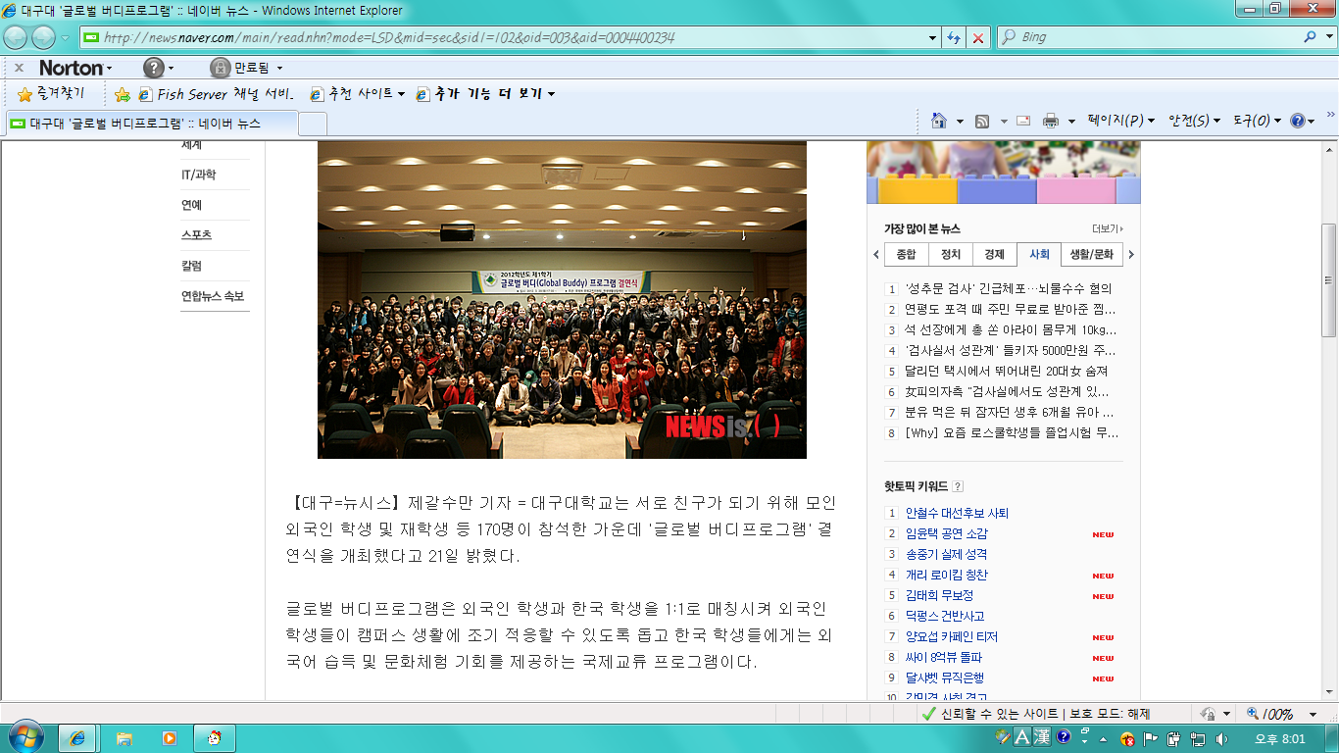

Therefore, in the short-term program planning challenges that foreigners and one-on-one to communicate with each other, and once during a program at the school next year, but a program called Buddy.

Through the program will develop the ability to communicate directly with foreign.

Studying through the book only when it comes to trade and communicate with foreigners think no avail. Well, even if they are not directly hit a little to increase proficiency in a foreign language through dialogue, think.

Trader Trading Company International Certification favorable. Plans to study a few in the crowd would be attending the academy to determine the current public administration and the students themselves as to.

In addition, computer literacy and computer-related MOS also need to plan to take. Difficult to a lot of things in the short term, I think you can, but the time is never short time.

Difficult and tricky at first, but little by little it is the end goal bondamyeon not think it can be achieved.

Medium-term plan

When one considers the short-term planning in the distant future a little more planning,

Seah Trading Company in order to get a job specification will be ready. Lack of more study in order to get a job.

Seah trading company involved in the mind will be convinced that the pledge to go up while learning a lot too. Thinks so, will be considered by a Seah Trading Company eventually get a job myself look.

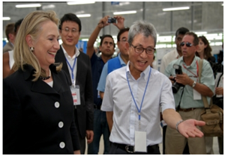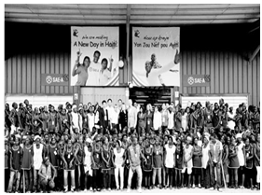<Seah By proceeding>

Theory is important, rather than trading company that practice is important occupations. However, I jump kicking Been Looking smashing directly into the body is to broaden the horizons.

There are a variety of trade goods that can be. My plan will be mainly fashion trade. Always was interested in fashion, and the others are pursuing fashion. In other words, fashion is only limited to clothes, rather than the consequent additional things the new configuration, try thinking.

And trading company, also relative simple finance business, production, buyers are divided into various categories, and so on can be divided into. Thing I want to do is relative to the buyers.

Fashion companies, especially in Korea, they are produced in China and Southeast Asia to.

So I foreign language skills are important, but you must have the physical strength and personality. Colorful fashion water works to come out in the back, followed by a harsh environment.

While staying on domestic production or finance job is not so bad, but I think if you look at the distant future relative to the buyers to believe it is helpful to me.

5-year time buyers during manna yeomen I'm thinking of trying some hands-on experience of the trading company. Relative to a job at a trading company and a buyer likes a seemingly as mentioned above may seem a tough job, if you look at the background. In other words, in order to survive over the long term, trading company from a variety of hands-on experience is necessary. It is important to understand people's tastes go overseas, find out the current local situation. And buyers remain in a trading company that is not bad, but the goal of future goal is to establish a trading company, the best thing my name. Wished to gain practical experience of trading company know how to read the flow of the times, it is necessary to me.

Long-term plan

Long-term plan for the future when it comes to that, as I mentioned earlier, my name Gun Trading Company will be established. You will need to know how to read the flow of this era in order to realize these plans, as I said. If you only adhere stable in the era of the former Goods, eventually yen, over time, I think that there is more development.

This is the case of our country, and many rely on exports. Development that reduced exports’ eventually think that the difficulty in the management of the company.

I themselves will continue to be the development. You do not have their development company as well. Trading company, as mentioned above, the seemingly cool look a lot of hard work back seamen follow. So after 10 years, if physically not seem like a lot of the old. Exercise self-management will also be steadily. And after 10 years, any country might be led to the World Trade. Wished to keep pace with the flow in a foreign language will also be studied.

10 years back, you are walking down the street in his mid-30s. May be the home of most of the acts. Trading companies neglect traveling to many relationships in the home can also. So my job to give a good understanding of your future wife wants to meet.

Would leave only dream memories… Be achieved… Surely will be done!!!!