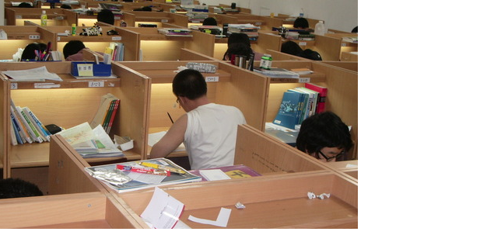

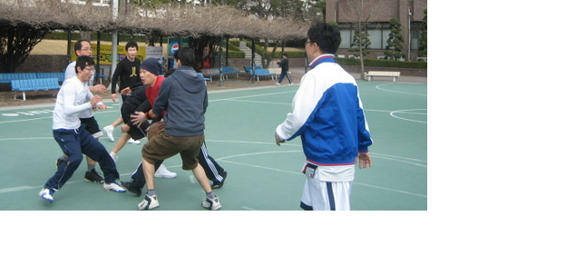

My dream is public officer. But above pictures don’t mean **public officer**. Above pictures have something in common. What is it? **Given everything effort hard**. I don’t want to be listened to lazy at least. Last semester lived in dormitory. I think that l become lazy. Because l awaked up 2 hour ago in lesson. For example, if lesson started 11am, I had waked up 9am. I was busy since I took a shower. I think that **important thing prepare lesson content**. Then l was discontent it. I decide to commute to school. I am very satisfactory. I practice well my dream. I am going to want to practice my dream.