My future 1 year, 5 year, 10-year plan

행정학과 3학년

20807321 송상훈

I am SongSangHun running from the current university. I make, and I will see my dream one year front. The future is my universities during preparation. I will make my future plan with in range largest called school. My dream is for National Agricultural Cooperative Federation government official to be. I entered school to the public administration department which is salted in order to enter National Agricultural Cooperative Federation first, but now I major in the plural form like horticulture excesses, and am learning. When National Agricultural Cooperative Federation government official was at public administration department, be devoted for being good at administrative business, and I am learning, I learn from characteristics about growth process of a plant and plants at a horticulture, It is learning how whether or not there is in the best ways to make no matter how much in order to grow a plant well. And a certificate of qualifications is preparing it. Even if it is a government official, personal specification is most important in order to get job at A company. It is today's actuality, and I am fitting it to this actuality. Of course, now I am still a step developing specification, and is learning as step-by-step, is fitting it to actuality, but I who am salted want to exchange this actuality. I am now 24 years old, and it is three grade. You shall stop the characteristics that you are, and four grade shall endeavor in ways to be different with people to be different in order to you shall get really job, and to achieve my dream, and I only have now if it is the next year. When we enter a company, or a government official is, you shall publish a personal resume. A personal history is to be able to inform the person oneself to sentences. I wish for thing, and to want it with Specification of a company government official or a level to be high to contents of a resume in a lot of places am a resume a resume informing the person oneself to sentences in examples. But I will complete a graduation certificate with a graduation certificate of public administration department and a horticulture as now a former resume is going along the world so that National Agricultural Cooperative Federation government official becomes it, There are two months of careers that I worked now related to an agricultural village. I will accumulate a career while working to this vacation dirt in agricultural chemicals companies. And I will acquire a computer accounting certificate of qualifications. I study little by little during four grade of dirt terms, and I learn from the TOEIC, and I acquire a TOEIC score, and vacation dirt is a mouth during thoughts while going to an institute. And I think that it is way this which is the best that it is delivered to thing good really to a university, and I go to a school, and a government official becomes, but I am considered that true it stood when I am thin that it is some length having been hard. The place that agricultural chemicals need as I am looking at gardening National Agricultural Cooperative Federation and the necessary earth, You shall know it about agricultural chemicals, Growth process of a plant shall know it. And my Uncle is to National Agricultural Cooperative Federation. Therefore, anything will recognize need is more in order to get job to uncle to National Agricultural Cooperative Federation. And there is the reason that the reason that I wanted to enter to National Agricultural Cooperative Federation is as limping uncles are to National Agricultural Cooperative Federation, I like an agricultural village. However, population decreased recently on actuality very much to an agricultural village, A lot of people are going to a city realistic, and population is continuously decreasing to an agricultural village, and is a point of time. Therefore, labor force is very short in agricultural villages, Mechanization will work, As there aren't young people to an agricultural village, I have a lot of the An old man which cannot treat a machine well. If I continuously join to these formulas, and I go out, an agricultural village will disappear. Then I may not see an organic farming, these fruits such as the food which our country people like. These figures can read it in National Agricultural Cooperative Federation. It is a figure of the people that together whets a briquette like neighbor mutual is divide it. On paper it is the academic graduation certificate and TOEIC not to mention me in order to get job at National Agricultural Cooperative Federation, I will have these things such as a certificate of qualifications, but it is success all the people speaking Thing called person calls it during a disguise, and I think in order to make it. Therefore, personal relations achieve it not being accumulating a career to be able to spend on salted these resume only well, and I will go out. Assets even learned that person wasn't able to exchange money even. And personal relations were important very in order to succeed, and I made it. These personal relations regard very it as important, and I will do it. These figures can read it very much in agricultural villages. Of course, I can watch these figures in a city. I go out very much if I see news or TV. But these figures are dailies in agricultural villages. As I like these figures, I cannot write on a resume, but the personal history that doesn't look will fill surely it very much.

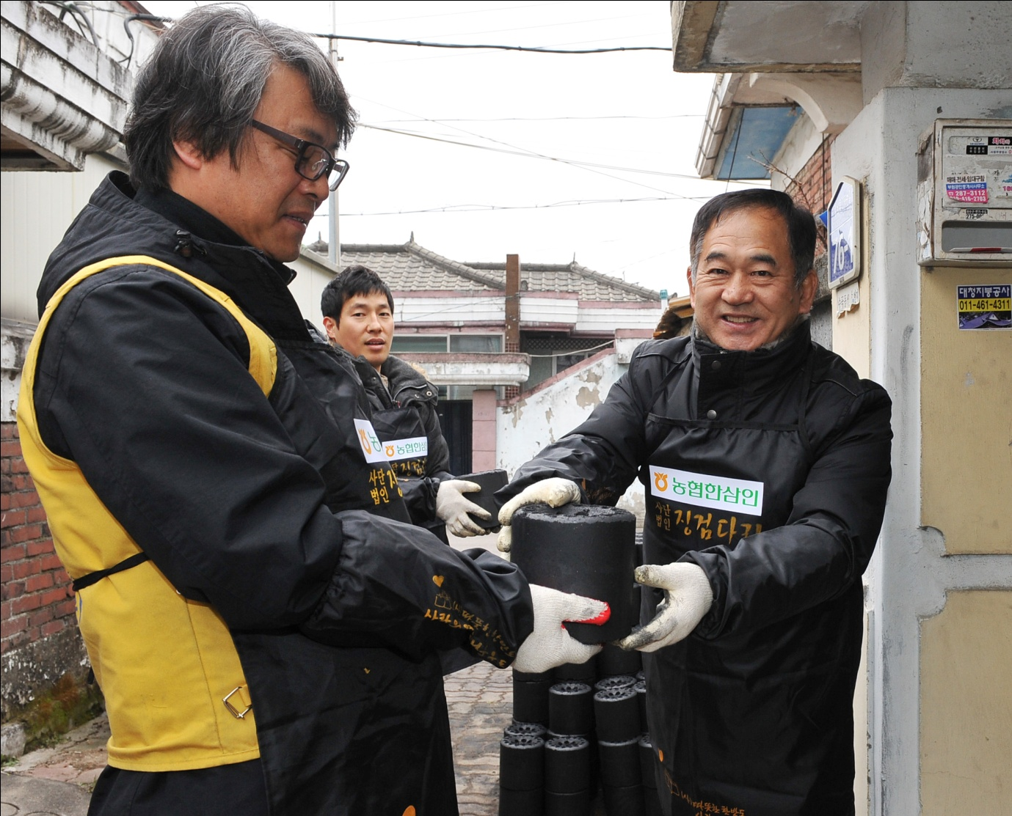

I make, and I will see in the future the five years front of me now. I get job to National Agricultural Cooperative Federation within five years, and I will learn slowly most from the following. And development calls my characteristics, ability to be salted if got job to National Agricultural Cooperative Federation, and other person will bring up what I cannot do. Today's entertainer debuted to a singer if I see it, but there is the person whom a person doing an entertainer has you, and is doing a musical. Professional of the world, diversification worked, and a lot of people are doing recently multiplay. Therefore, I will be doing it even if I get job at salted National Agricultural Cooperative Federation, and I settle other work related to National Agricultural Cooperative Federation daily routine National Agricultural Cooperative Federation. Me the crops are personally poor very at pest. Therefore, I want to try to make the strong crops to pest. For example, strawberry is a white powdered disease, but is poor very at anthracnose etc. Therefore, crops called strawberry which was for the first time in nation strong became development. I want to try to develop in this way new crops. If development works while working in National Agricultural Cooperative Federation as I study individually crops, I want to try development. And I am thinking even if I went insane in salted National Agricultural Cooperative Federation, and an enemy gives that it is the true work that wants to try.

While there is it to National Agricultural Cooperative Federation salted in my ten years inside and outside with main occupations, I make together agriculture, and I will be living in the future. And I will have developed the fruits which is strong to pest while recognizing whether or not I experience directly agriculture while I learn in theory very much in National Agricultural Cooperative Federation, and I consider it to work, and going, and fruits opens more well. And a process or a way for agricultural village public information very does it while I work in this way to be hardly it, and will enlarge personal relations, and young people to make with the fruits which is excellent to people in an agricultural village to an agricultural village will inform it. Therefore, I will save again the agricultural village that will stop now very much. Me a marriage will call it to the ten years inside and outside. Now 34 years old to be salted if the ten years back works as it is 24 years old are made. I meet a person, and a marriage will call it that I loved. And I will endeavor to National Agricultural Cooperative Federation salted to the ten years inside and outside so as to be able to bring up excellent talented persons very much. Of course, one other talented persons getting job to National Agricultural Cooperative Federation only will help it so as to be able to have personal ability in many quarters not being working. I walk will do effort so as to be able to give a lot of help if is thinking that is long, and a lot of people will go to other course even, and there is a thin person to a street like me.